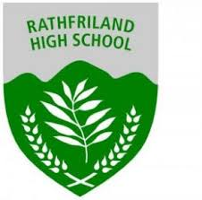
Rathfriland High School Rugby
Match Date | 04/10/22
Opposition | Drumglass High
Venue | Away
KO Time | 2.30pm

First Name | Surname | Year | Position | Duty | Special Instructions
Toby | Johnston | 11 | Loose Head |  | Meet at reception @ 1.05pm.  Full Rathfriland Rugby Kit must be worn. Green Rugby Shirt, Black Rugby Shorts, Rugby Socks and Boots  ETA back at school will be roughly 4/4.30pm so please arrange alternative transport home as you will miss the bus.  All players to bring their own water bottles.
Edward | Harbinson | 11 | Hooker
Harry | Bingham | 11 | Tight Head
Tommy | Cochrane | 11 | Second Row
Albert | Jackson | 11 | Second Row
Matthew | Macauley | 11 | Blindside
Jack | Morrow | 12 | Openside
Thomas | Skelly | 11 | Number 8
Zach | Wharton | 11 | Scrum Half
Joseph | Trimble | 12 | Fly Half | Vice-Captain
Robin | Mitchell | 11 | Left Wing
Joel | Johnston | 12 | Inside Centre | Captain
Harry | Bready | 12 | Outside Centre
Callum | Moore | 12 | Right Wing
Zach | Warburton | 11 | Full Back
Rhys | Hillis | 12 | SUB
Toby | Magill | 12 | SUB
Ethan | Parke | 12 | SUB
Taylor | Vassey | 11 | SUB
Cody | Barr | 11 | H20
Bobby | Pyper | 11 | H20

